**Project Team 501-05: Readme File**

**Step 1**: Install pHp and SQL using [MAMP](https://www.mamp.info/en/). The website will look like below.

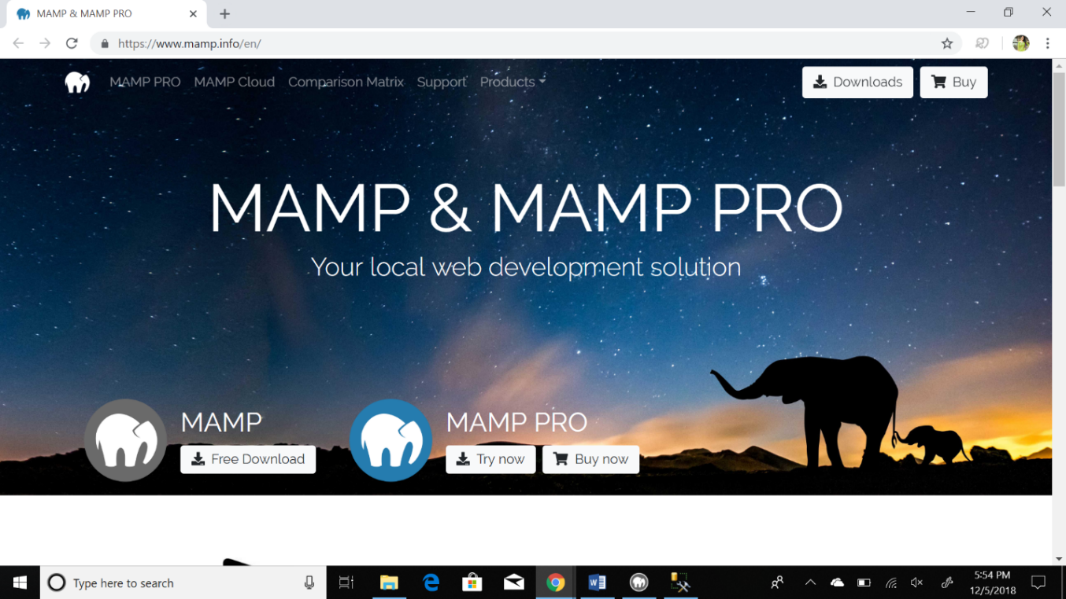

**Step 2**: On opening MAMP, a window like below will appear.

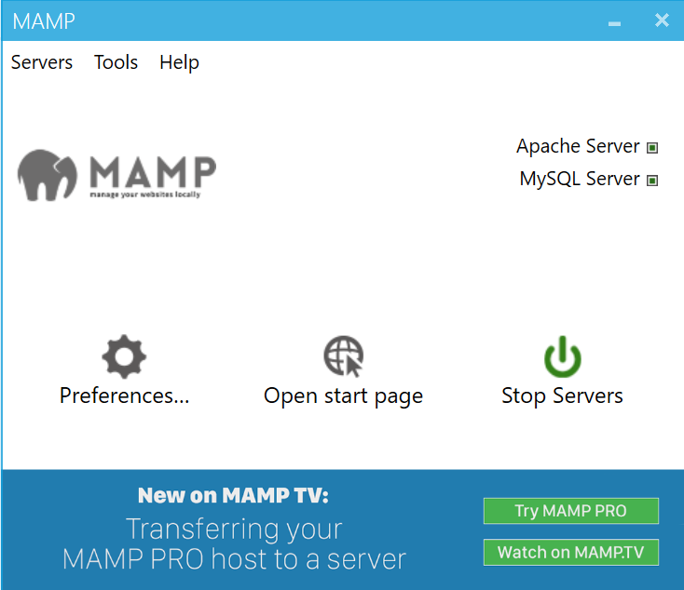

**Step 3**: Go to preferences, toggle to Web server and set a desirable path where all the pHp and HTML files will be imported.

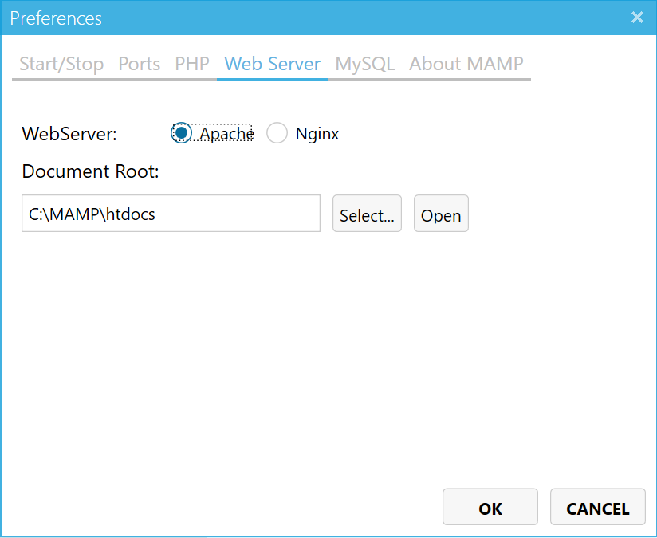

**Step 4**: Go to the MAMP window and click on Open Start Page. A web page which looks like the screenshot below will appear.

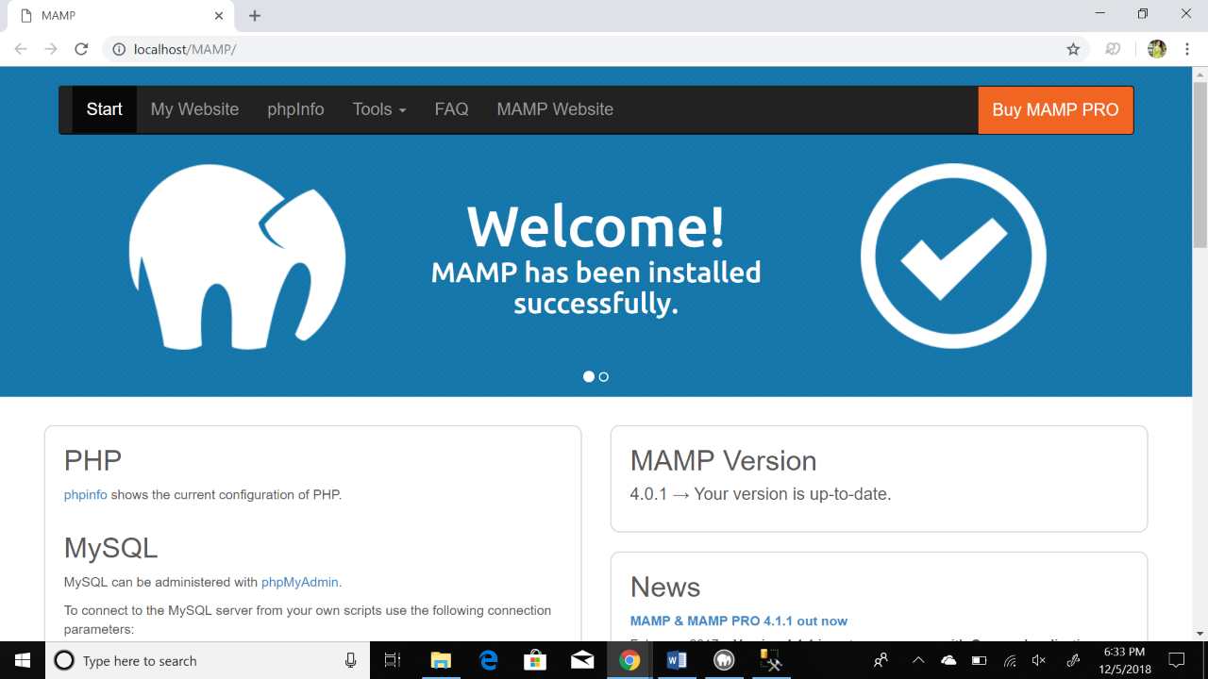

**Step 5**: Click on the phpMyAdmin under MySQL. In the window that appears, click on SQL. Here, a database can be created. The interface looks like below.

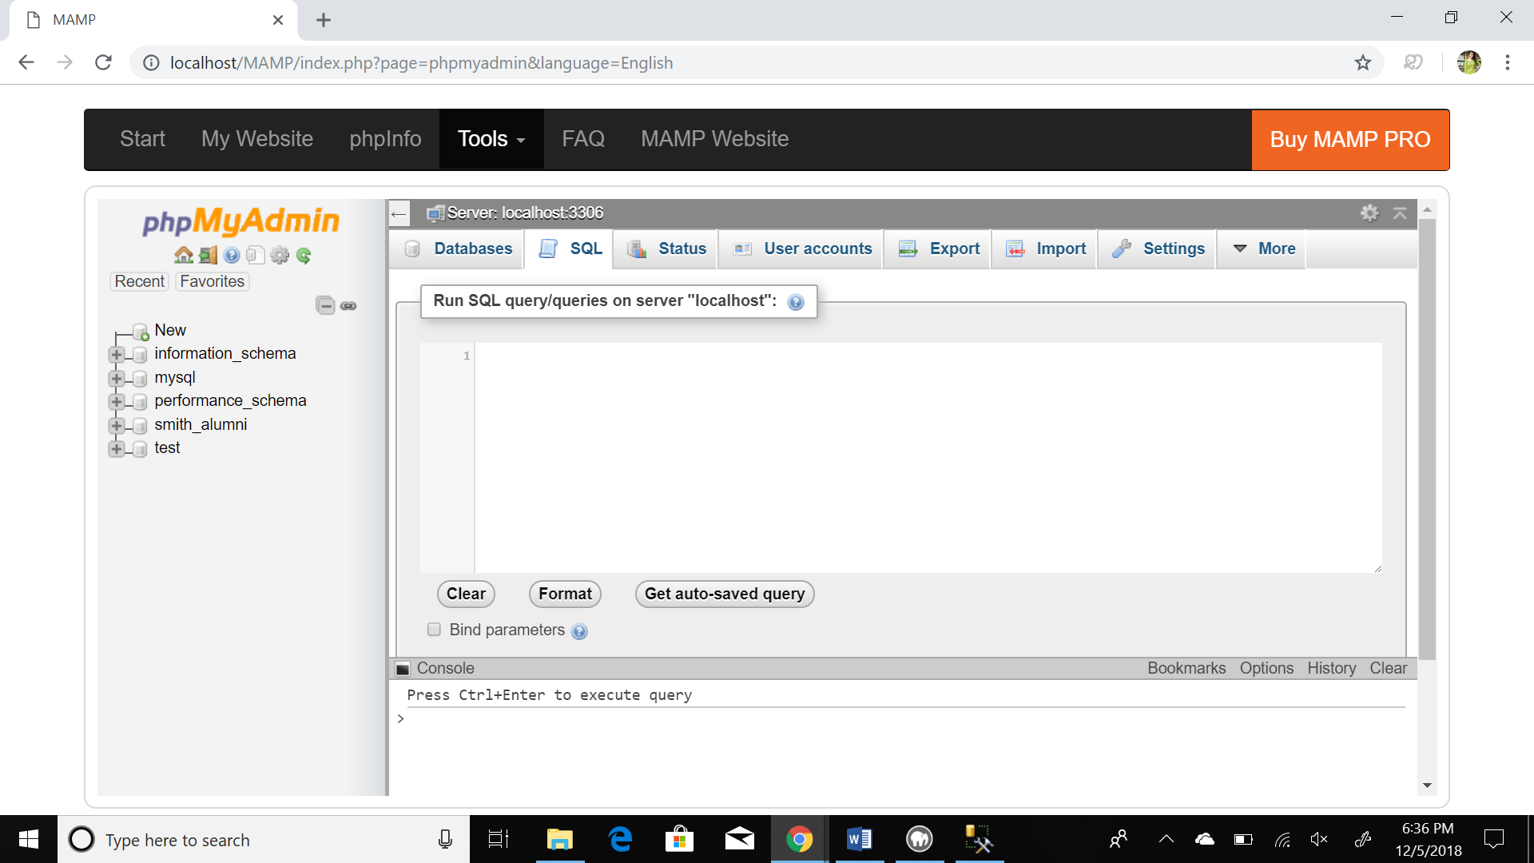

Run the .sql code given in the folder. It will look like the following with database name as smith.alumni which contains 8 tables and the views smith_uc and smith_all

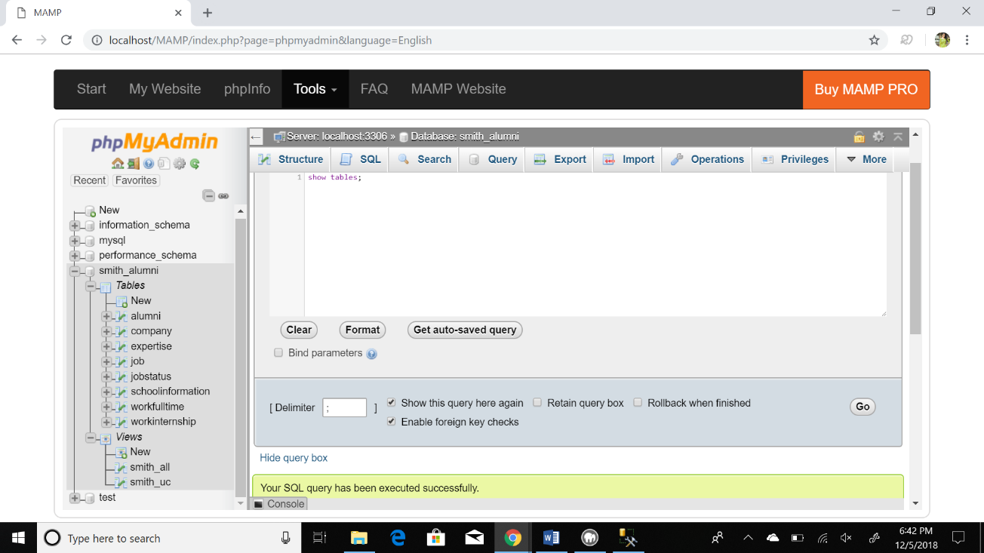

**Step 6**: Copy the .pHp, .html and .css files into the path selected earlier in MAMP -> Preferences -> Web server.

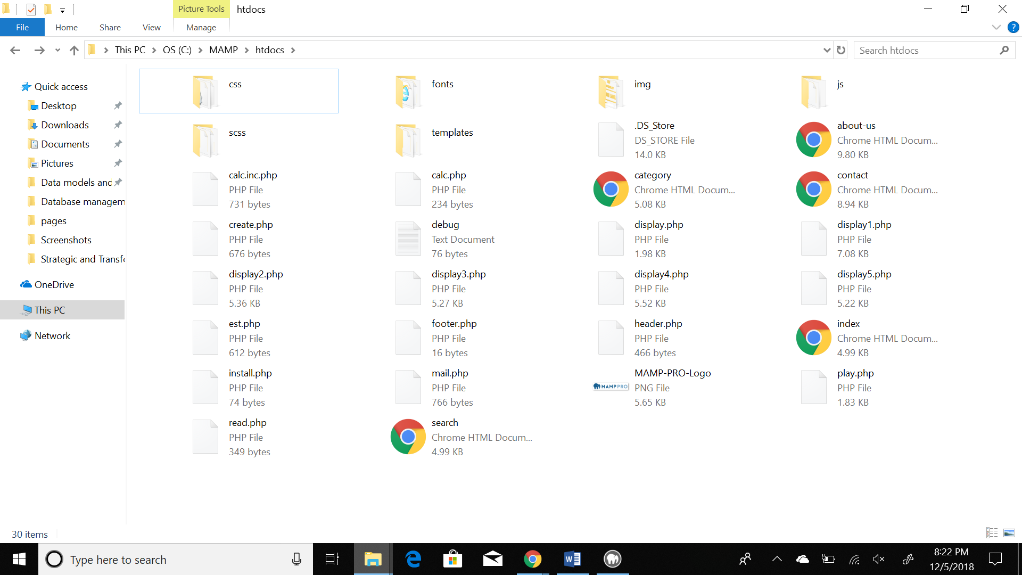

**Step 7**: Open browser and run localhost (for Windows) and localhost:8888 (on Mac). The following page will display.

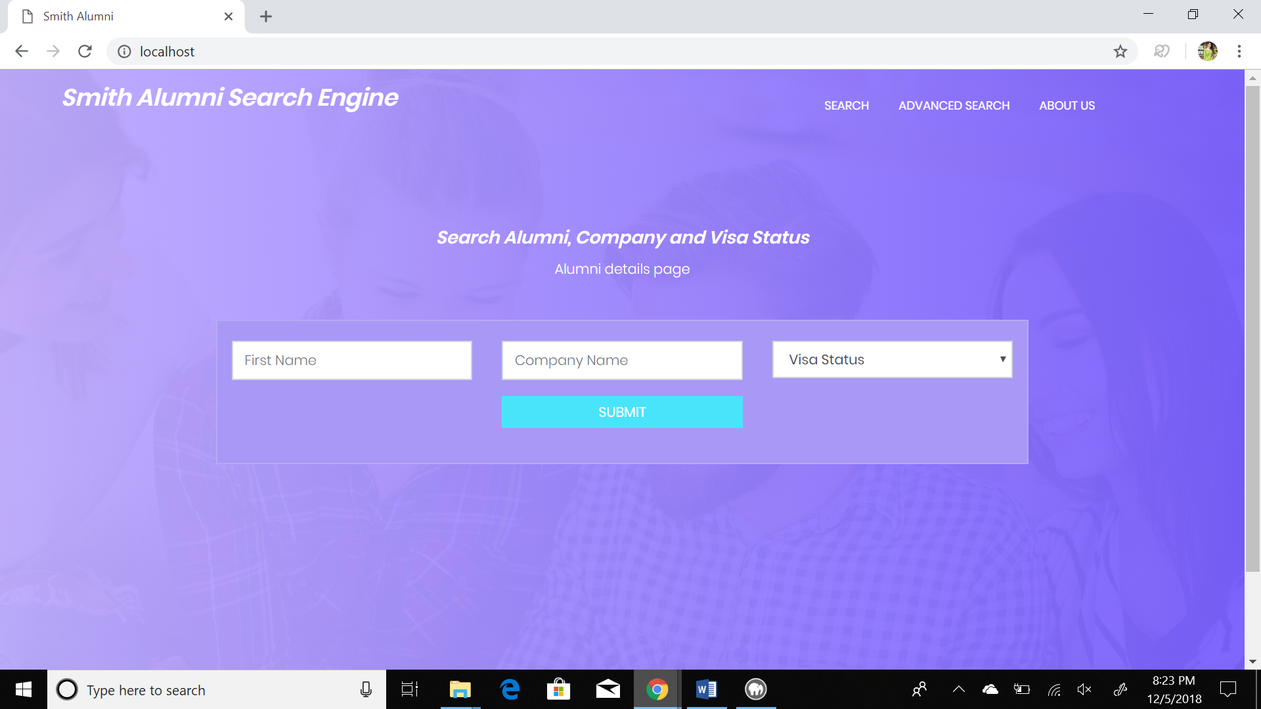

In this page, search can be conducted on the basis of First name, Company name or Visa status.

1. Below screenshot is of the result obtained when searched for ‘Gauri’ in the above ‘First Name’ text box

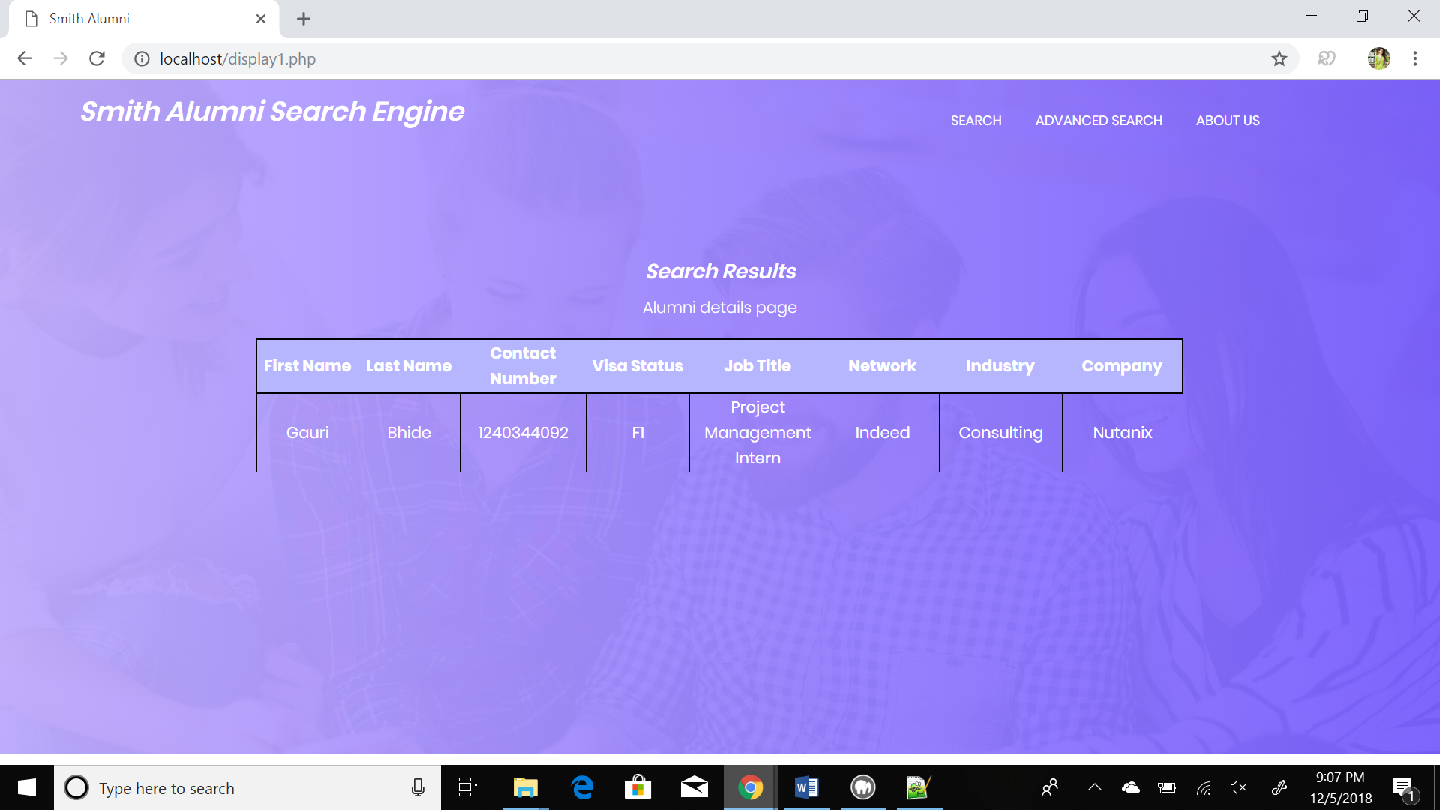

1. Below screenshot is of the result obtained when searched for ‘zs’ in the above ‘Company Name’ text box

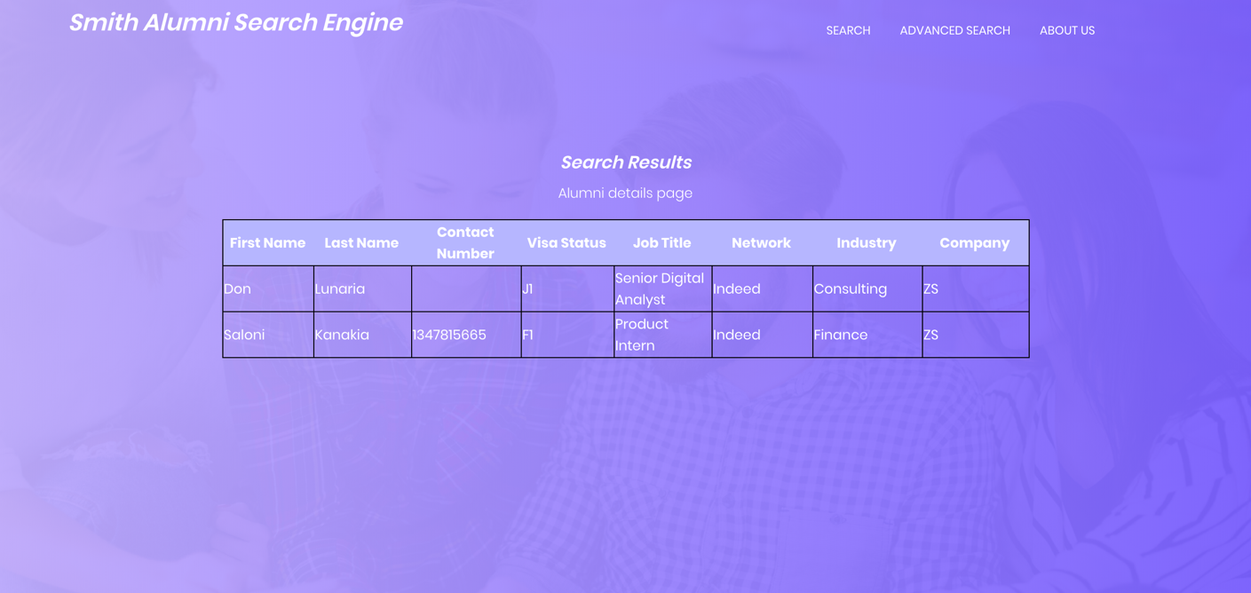

1. Below screenshot is of the result obtained when ‘Citizen’ is selected in the above ‘Visa Status’ text box

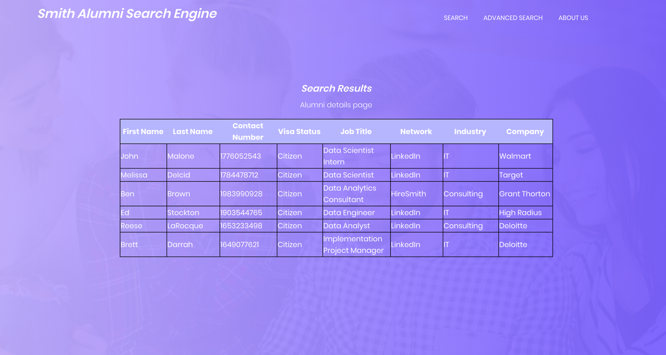

1. User can also do a combined search for alumni details by any combination of these three text boxes. Below is the screenshot of the result obtained when ‘ZS’ is selected as the ‘Company Name’ and ‘F1’ is selected in the above ‘Visa Status’ text box

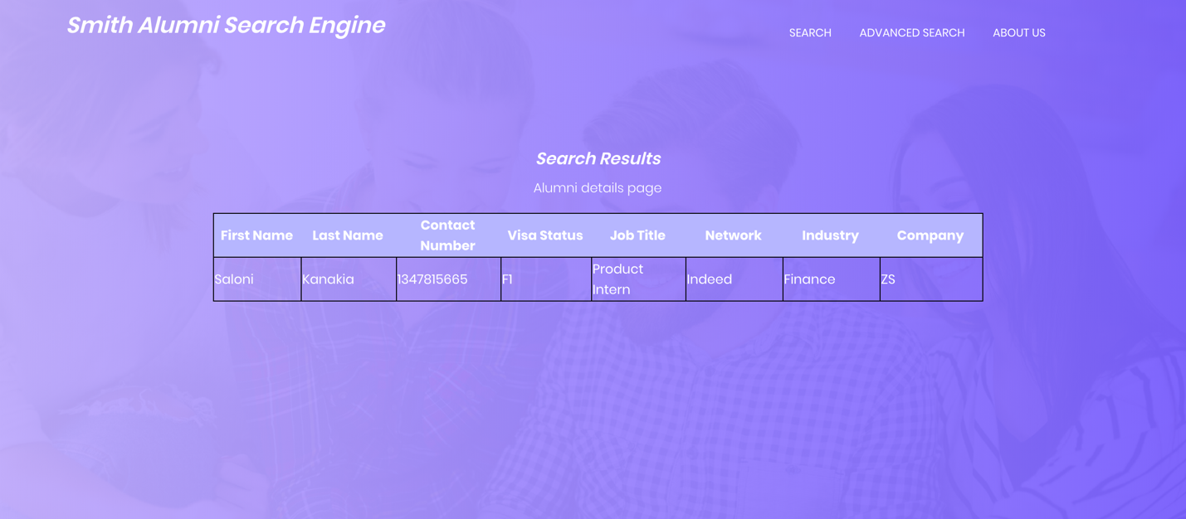

**Step 8**: In case the user wants to search in terms of other keywords, advanced search can be conducted by clicking on the icon ‘ADVANCED SEARCH’.

Advanced search looks like the following.

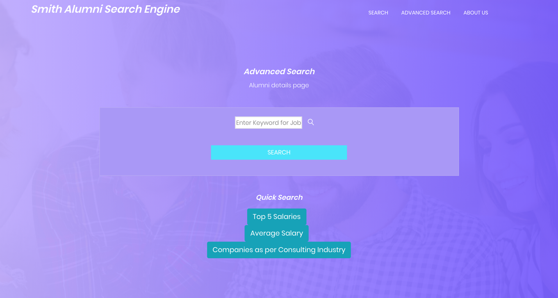

The user can enter any keyword pertaining to the job title and obtain the corresponding results.

Following example is the result when searched for ‘business’ in the input box above:

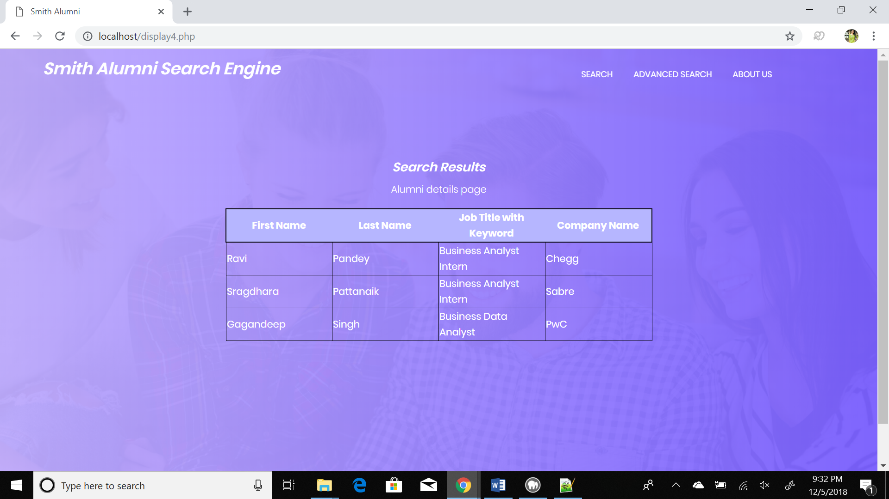

**Step 9**: There are quick search options as well which makes the user’s search a lot easier and faster.

1. Top 5 Salaries – User can see the details of the alumni who have top 5 salaries in the database

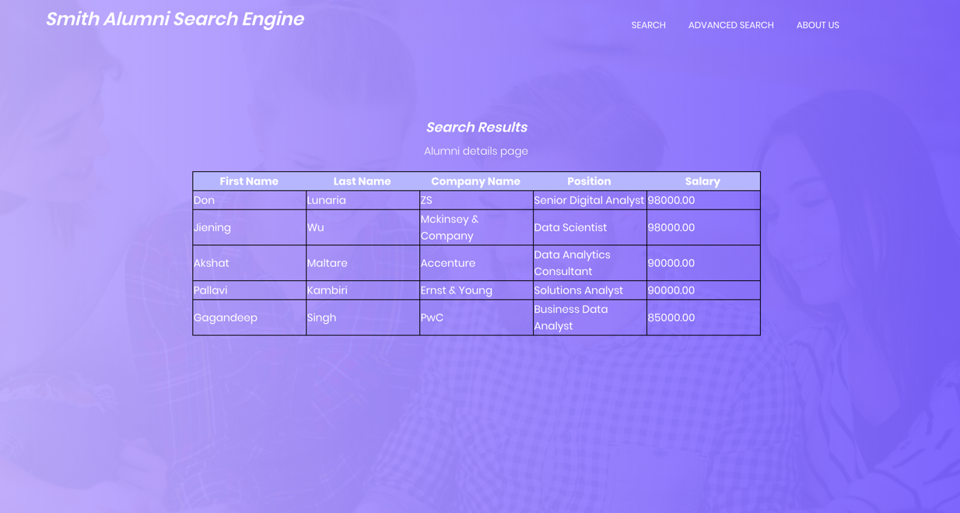

1. Average Salary - User can see the average salary among all the alumni in the database



1. Companies as per Consulting Industry – User can see all companies which have provided jobs in the Consulting Industry, this helps in discerning the company where user can apply to

